**PROJECT REPORT**

(Project Term June-December 2021)

**COLOUR DETECTION**

Submitted by

**SAURAV 11914887**

**INT 246**

**(B. Tech CSE)**

Under the Guidance of

**Dr. Sagar Pande**

# School of Computer Science and Engineering

**LOVELY PROFESSIONAL UNIVERSITY**

**PHAGWARA, PUNJAB**



**DECLARATION**

We hereby declare that the project work entitled Colour Detection is an authentic record of our own work carried out as requirements of Project for the award of B. Tech degree in Computer Science and Engineering from Lovely Professional University, Phagwara, under the guidance of Sagar Pande, during August to November 2021. All the information furnished in this project report is based on our own intensive work and is genuine.

**Name of Student:** Saurav

**Registration Number:** 11915238

Saurav

Date: 20-11-2021

**CERTIFICATE**

This is to certify that the declaration statement made by this student is correct to the best of my knowledge and belief. They have completed this Project under my guidance and supervision. The present work is the result of their original investigation, effort, and study. No part of the work has ever been submitted for any other degree at any University. The Project is fit for the submission and partial fulfillment of the conditions for the award of B. Tech degree in Computer Science and Engineering from Lovely Professional University, Phagwara.

**Name of the Mentor:** Dr.Sagar Pande

**School of Computer Science and Engineering,**

Lovely Professional University,

Phagwara, Punjab.

# ACKNOWLEDGEMENT

*I am overwhelmed in all humbleness and gratefulness to acknowledge my depth to all those who have helped me to put these ideas, well above the level of simplicity and into something concrete.*

*I would like to express my special thanks of gratitude to my teacher DR. SAGAR PANDE who gave me the golden opportunity to do this wonderful project on the topic* ***COLOUR DETECTION***

*, which also helped me in doing a lot of Research and i came to know about so many new things. I am really thankful to them.*

*Any attempt at any level can ‘t be satisfactorily completed without the support and guidance of MY parents and friends.*

*I would like to thank my Friends who helped me a lot in gathering different information, collecting data and guiding me from time to time in making this project, they gave me different ideas in making this project unique*

**TABLE OF CONTENTS**

Title Page……………………………………………………………………………(1)

Declaration…...……………………………………………………………………...(2)

Certificate……..…….……………………………………………………………….(3)

Acknowledgement…………………...…………………………………………........(4)

Table of Contents……………………...…………………………………………….(5)

1. What is colour detection
2. About the colour detection project
3. Dataset
4. Prerequisites
5. Steps for Building colour detection
6. Output
7. Conclusion
8. Bibliography

**1. What is colour detection**

Colour detection is the process of detecting the name of any color. Simple isn’t it? Well, for humans this is an extremely easy task but for computers, it is not straightforward. Human eyes and brains work together to translate light into color. Light receptors that are present in our eyes transmit the signal to the brain. Our brain then recognizes the color. Since childhood, we have mapped certain lights with their color names. We will be using the somewhat same strategy to detect color names.



### About the Colour Detection Project

In this color detection Python project, we are going to build an application through which you can automatically get the name of the color by clicking on them. So for this, we will have a data file that contains the color name and its values. Then we will calculate the distance from each color and find the shortest one.

### The Dataset

Colors are made up of 3 primary colors; red, green, and blue. In computers, we define each color value within a range of 0 to 255. So in how many ways we can define a color? The answer is 256*256*256 = 16,581,375. There are approximately 16.5 million different ways to represent a color. In our dataset, we need to map each color’s values with their corresponding names. But don’t worry, we don’t need to map all the values. We will be using a dataset that contains RGB values with their corresponding names. The CSV file for our dataset has been taken from this link:

<https://drive.google.com/file/d/1wu311C51EJ8CRJHXjWqzhUpZxVQ4fdaz/view?usp=sharing>

The colors.csv file includes 865 color names along with their RGB and hex values.

### Prerequisites

OpenCV, Pandas, and numpy are the Python packages that are necessary for this project in Python. To install them, simply run this pip command in your terminal:

Pip install opencv-python numpy pandas

## Steps for Building Color Detection

### 1.Taking an image from the user

We are using argparse library to create an argument parser. We can directly give an image path from the command prompt:

CODE:

import argparse

ap = argparse.ArgumentParser()

ap.add_argument('-i', '--image', required=True, help="Image Path")

args = vars(ap.parse_args())

img_path = args['image']

#Reading image with opencv

img = cv2.imread(img_path)

### 2.Next, we read the CSV file with pandas

The pandas library is very useful when we need to perform various operations on data files like CSV. **pd.read_csv()** reads the CSV file and loads it into the pandas DataFrame. We have assigned each column with a name for easy accessing.

CODE:

#Reading csv file with pandas and giving names to each column

index=["color","color_name","hex","R","G","B"]

csv = pd.read_csv('colors.csv', names=index, header=None)

### 3.Set a mouse callback event on a window

First, we created a window in which the input image will display. Then, we set a callback function which will be called when a mouse event happens.

CODE:

cv2.namedWindow('image')

cv2.setMouseCallback('image',draw_function)

### 4.Create the draw_function

It will calculate the rgb values of the pixel which we double click. The function parameters have the event name, (x,y) coordinates of the mouse position, etc. In the function, we check if the event is double-clicked then we calculate and set the r,g,b values along with x,y positions of the mouse.

CODE:

def draw_function(event, x,y,flags,param):

if event == cv2.EVENT_LBUTTONDBLCLK:

global b,g,r,xpos,ypos, clicked

clicked = True

xpos = x

ypos = y

b,g,r = img[y,x]

b = int(b)

g = int(g)

r = int(r)

### 5.Calculate distance to get color name

We have the r,g and b values. Now, we need another function which will return us the color name from RGB values. To get the color name, we calculate a distance(d) which tells us how close we are to color and choose the one having minimum distance.

Our distance is calculated by this formula:

d = abs(Red – ithRedColor) + (Green – ithGreenColor) + (Blue – ithBlueColor)

def getColorName(R,G,B):

minimum = 10000

for i in range(len(csv)):

d = abs(R- int(csv.loc[i,"R"])) + abs(G- int(csv.loc[i,"G"]))+ abs(B- int(csv.loc[i,"B"]))

if(d<=minimum):

minimum = d

cname = csv.loc[i,"color_name"]

return cname

### 6.Display image on the window

Whenever a double click event occurs, it will update the color name and RGB values on the window.

Using the **cv2.imshow()** function, we draw the image on the window. When the user double clicks the window, we draw a rectangle and get the color name to draw text on the window using **cv2.rectangle** and **cv2.putText()** functions.

CODE:

while(1):

cv2.imshow("image",img)

if (clicked):

#cv2.rectangle(image, startpoint, endpoint, color, thickness) -1 thickness fills rectangle entirely

cv2.rectangle(img,(20,20), (750,60), (b,g,r), -1)

#Creating text string to display ( Color name and RGB values )

text = getColorName(r,g,b) + ' R='+ str(r) + ' G='+ str(g) + ' B='+ str(b)

#cv2.putText(img,text,start,font(0-7), fontScale, color, thickness, lineType, (optional bottomLeft bool) )

cv2.putText(img, text,(50,50),2,0.8,(255,255,255),2,cv2.LINE_AA)

#For very light colours we will display text in black colour

if(r+g+b>=600):

cv2.putText(img, text,(50,50),2,0.8,(0,0,0),2,cv2.LINE_AA)

clicked=False

#Break the loop when user hits 'esc' key

if cv2.waitKey(20) & 0xFF ==27:

break

cv2.destroyAllWindows()

### 7.Run Python File

The beginner Python project is now complete, you can run the Python file from the command prompt. Make sure to give an image path using ‘-i’ argument. If the image is in another directory, then you need to give full path of the image:

CODE:

python color_detection.py -i <add your image path here>

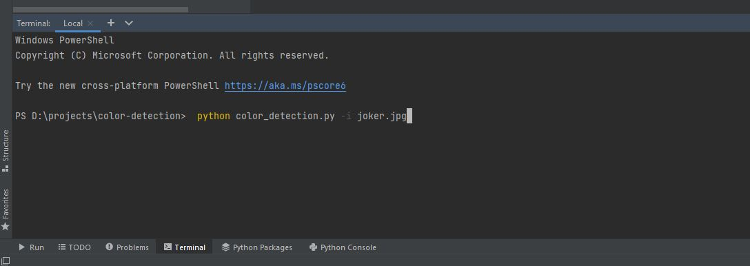

SCREENSHOT:

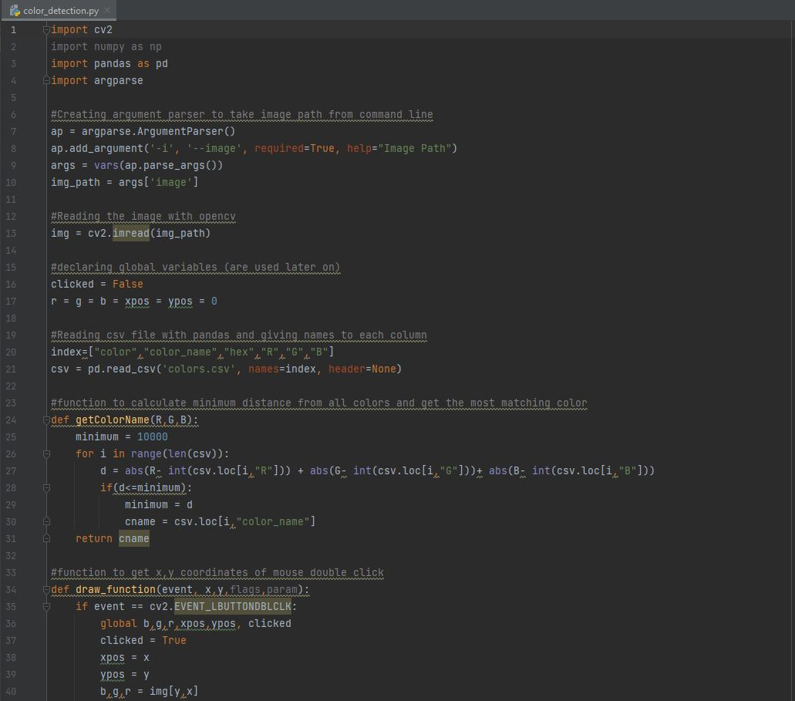

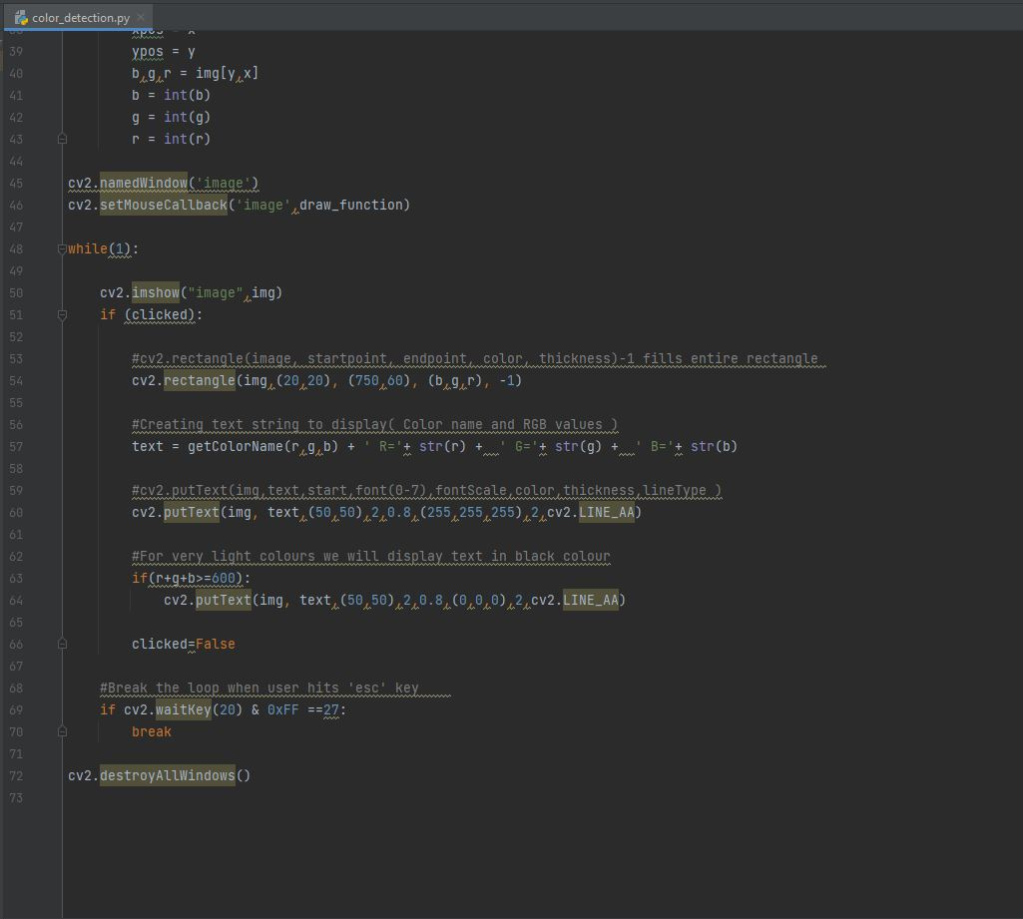

**Output:**

Double click on the window to know the name of the pixel color

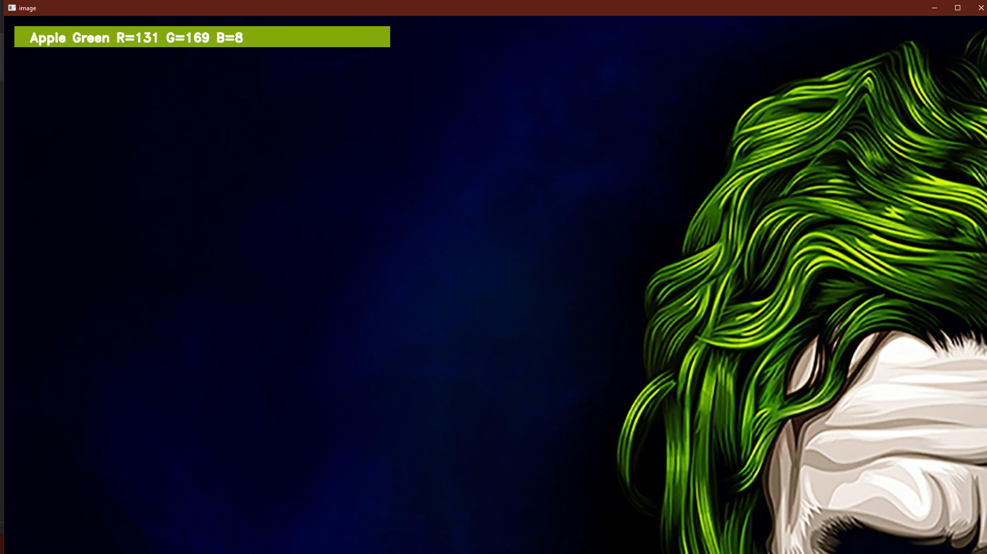

**CONCLUSION**

In conclusion, artificial intelligence will become more valuable to humans than its capabilities. It will become a part of our daily lives. Some worry about the development of this new technology where a robot that can learn and develop skills on its own. Artificial intelligence will surpass humans on an IQ level and become better than humans at many skills or knowledge. This leaves some people in an identity crisis. Why makes humans so unique and what is their purpose if artificial intelligence can simply replace them by taking all of their traits and habits? Artificial intelligences are designed to learn on their own and resemble a human brain and physical and mental properties. One thing is for sure, is that artificial intelligence will continue to develop because of humans. Humans will continue to make new discoveries and discover new things. Artificial intelligence will never be able to accomplish that, however they may assist a human by providing theories. The future is unknown and maybe artificial intelligence and humans will be able to work together on many different topics.

# BIBLIOGRAPHY

<http://www.python-course.eu/lambda.php>

<http://python-3-patterns-idiomstest.readthedocs.io/en/latest/Comprehensions.html>

<https://python.swaroopch.com/functions.html>

<http://anh.cs.luc.edu/python/hands-on/3.1/handsonHtml/functions.html>